Lecture 2. PLPA638/BIOGD638

March 30, 2005

Exercise 1:

Three point cross
 | Genotype of progeny | Number of progeny | Progeny type
wild type, pigmented, prototroph | ALB;TRP;LEU | 256
albino; prototroph | alb;TRP;LEU | 35
pigmented, requires tryptophan | ALB;trp;LEU | 55
pigmented, requires leucine | ALB;TRP;leu | 3
albino, requires tryptophan | alb;trp;LEU | 1
albino, requires leucine | alb;TRP;leu | 49
pigmented, requires tryptophan and leucine | ALB;trp;leu | 40
albino, requires tryptophan and leucine | alb;trp;leu | 262
ALB = pigmented, alb = albino
TRP = prototrophic for tryptophan; trp = requires tryptophan
LEU = prototrophic for leucine; trp = requires leucine

Write the genes in the correct order.
Fill in the right hand column in the table [parental, single crossover (sco), double crossover(dco)]
Calculate the frequency of recombination from the data and thus, the map distance between them.

Exercise 2:

Consider a two factor cross that yields 140 tetrads with the following configurations:
112 PD, 4 NPD, and 24 TT.

Calculate the map distance between the two genes (factors).

Exercise 3:

The following classes and frequencies of ordered tetrads were obtained in the cross AB X ab
in Neurospora.

Spore pair
1-2 | 3-4 | 5-6 | 7-8 | Number of asci
AB | AB | ab | ab | 1766
AB | ab | AB | ab | 220
AB | aB | Ab | ab | 14

What is the order of the genes in relation to the centromere?

Exercise 4: Mapping of Tox- mutations by tetrad analysis.
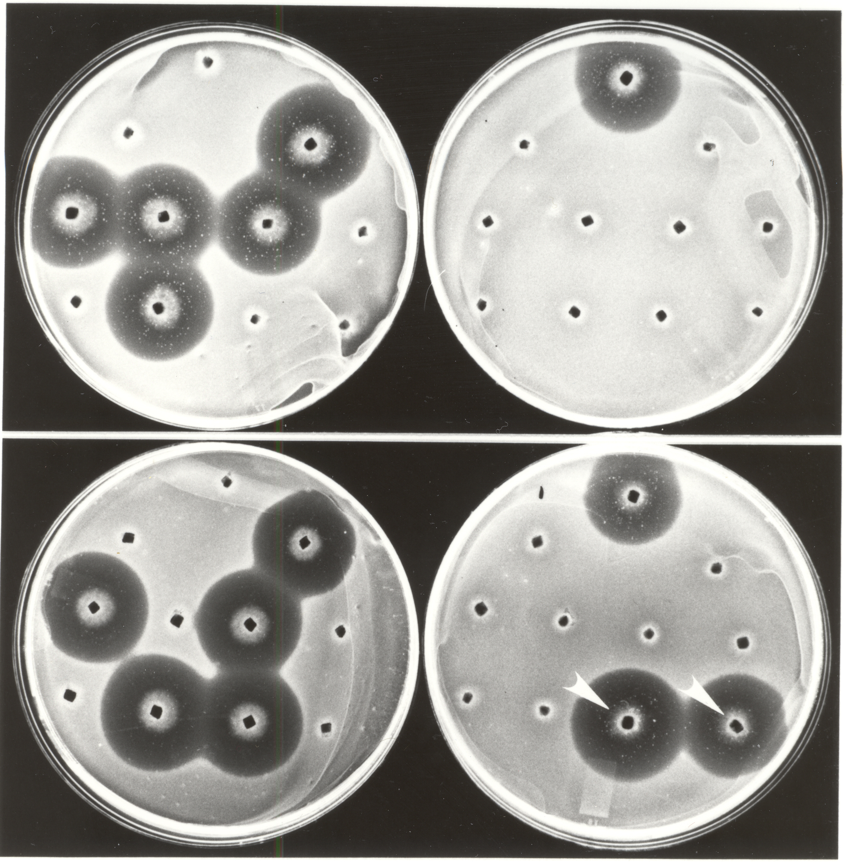
mutant
Tox+ tester
Tox- tester
Tox+
tox-
Mutant 1
Mutant 2

It is now well established that crosses between Cochliobolus heterostrophus race T, which produces T-toxin, and race O which does not produce T-toxin, segregate 1:1 for ability to produce T-toxin, indicating a single genetic locus (Tox1) involved in ability to produce toxin. In this experiment, the fungus was randomly mutagenized and tox- mutants collected. Mutants were analyzed by crossing to Tox+ and tox- tester strains. Shown here are assay plates for T-toxin production; plates are covered with a lawn of T-toxin-sensitive E. coli cells, then plugs of the fungus are placed on the plates. A halo indicates T-toxin is produced. In each plate the top three inocula are controls: mutant (left), tester parent (right), tox- or Tox+ control (top). The lower eight inocula represent a tetrad (four sets of twins) from a cross between tox- mutant 1 (top row) or mutant 2 (bottom row) and race T tester (plate on the left) or race 0 tester (plate on the right).

What do these crosses tell you about the number of genes affecting ability to produce T-toxin in each mutant?

What do these crosses tell you about linkage to the known Tox1 locus?

